CO4_AT3 - Comparative Analysis
Name: Lavanya
Regno: 192521271
Course name: Design and analysis of algorithms
Course code: CSA0613
Question 23
Title
Word Wrap Problem vs Job Sequencing with Deadlines – Dynamic Programming vs Greedy
1. Objective
To solve the Word Wrap Problem using Dynamic Programming and the Job Sequencing with Deadlines Problem using Greedy Algorithm, and compare their objectives, correctness, complexity, and applications.
2. Word Wrap Problem
The Word Wrap problem arranges words into lines of a fixed width. The objective is to minimize the unused spaces at the end of lines, called raggedness.
Complexity Analysis
Word Wrap
There are approximately n² possible pairs of words.
Therefore:
Time Complexity:
$$O\left(n^{2}\right)$$
Space Complexity:
$$O\left(n^{2}\right)$$Job Sequencing
Sorting the jobs requires:
$$O\left(n\log{n}\right)$$
Scheduling requires approximately:
$$O\left(nD\right)$$
where D is the maximum deadline.
Therefore:
$$O\left(n\log{n}+nD\right)$$

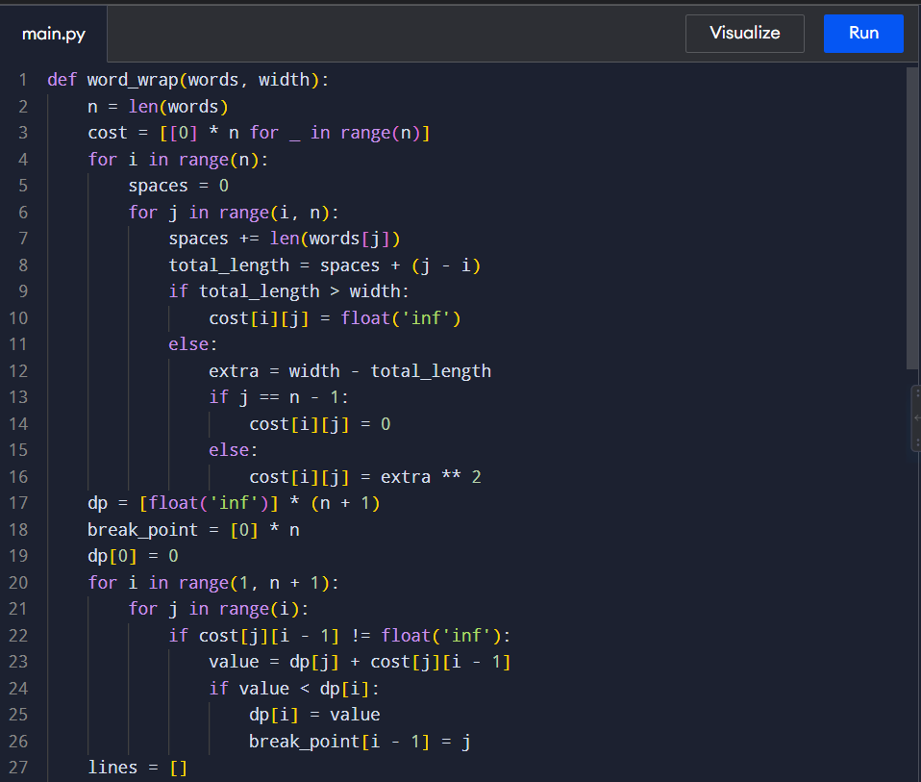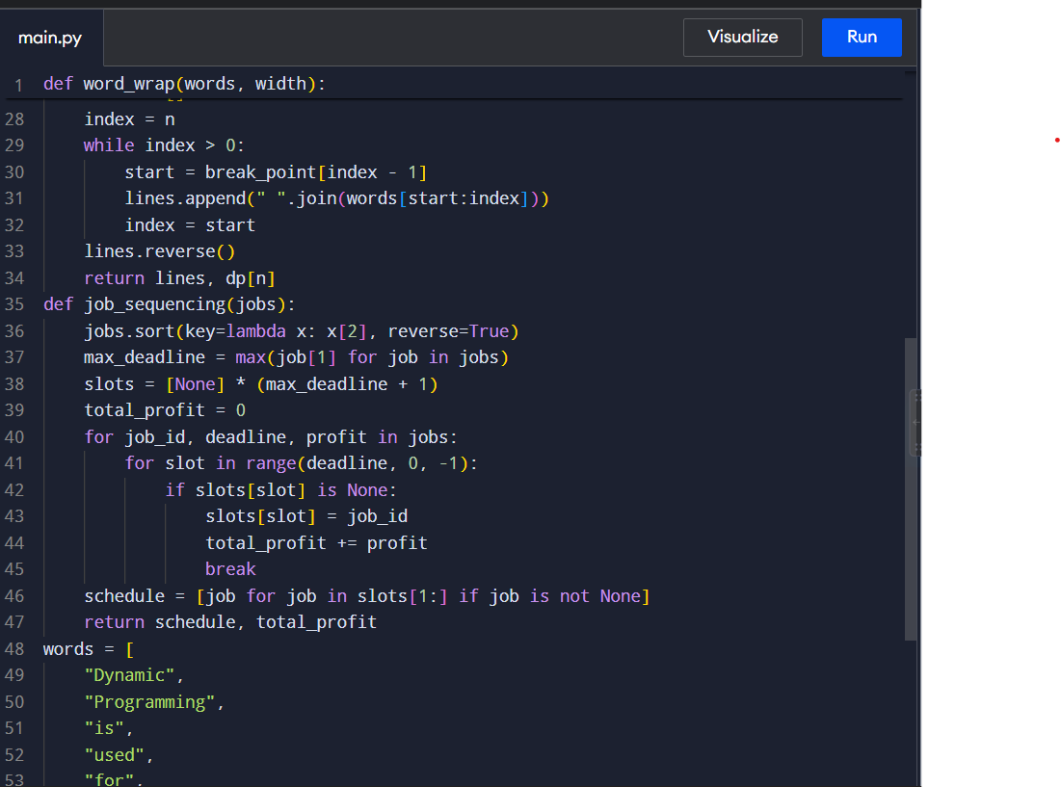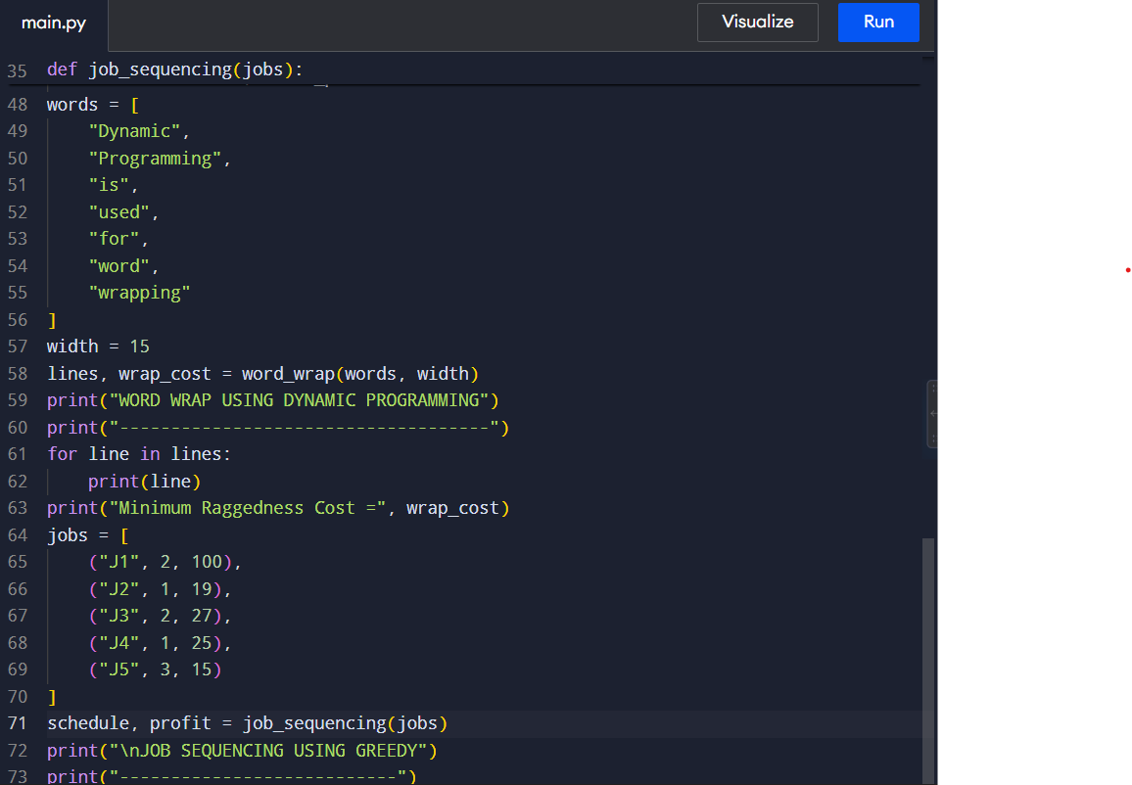

Input & Output
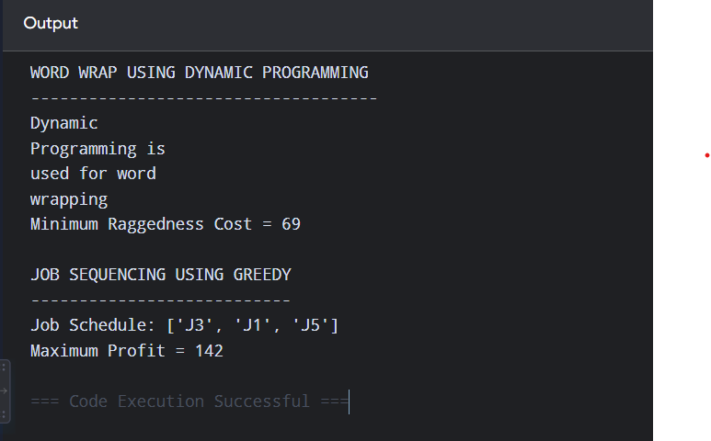

Conclusion
The Word Wrap Problem and Job Sequencing Problem demonstrate two important optimization techniques. Word Wrap uses Dynamic Programming because different line-break combinations need to be evaluated to minimize raggedness. Job Sequencing uses a Greedy approach because jobs can be selected based on profit while respecting deadlines. Thus, both algorithms achieve optimal results, but they use different strategies according to the structure and objective of the problem.

Documentation
Project: Word Wrap vs Job Sequencing
Algorithms: Dynamic Programming and Greedy
The Word Wrap problem arranges words within a fixed line width while minimizing unused spaces. Dynamic Programming calculates the cost of different word combinations and selects the arrangement with minimum raggedness.
The Job Sequencing problem schedules jobs with deadlines and profits. A Greedy algorithm sorts jobs by profit and places each job in the latest available slot before its deadline.
Word Wrap has approximately O(n²) time complexity, while Job Sequencing requires O(n log n + nD) time.
These algorithms are useful in text formatting, scheduling, production planning, and resource management.

